Phonics for Parents and Carers
Handout 4: Useful links

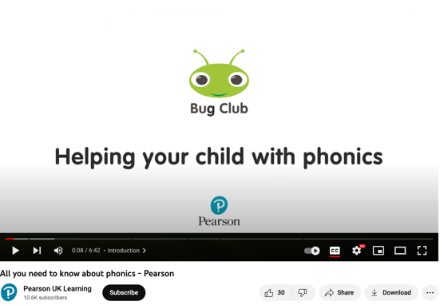
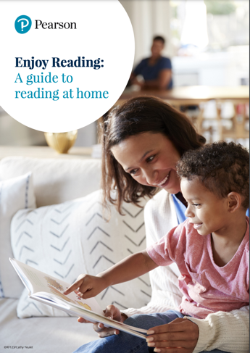
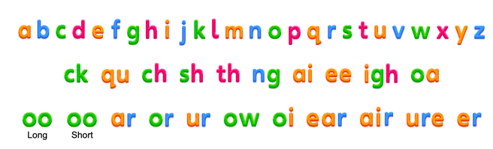
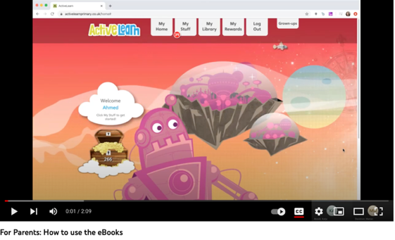
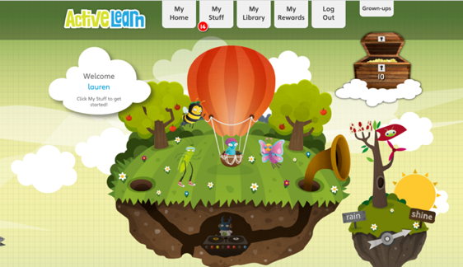
All you need to know about phonics video.

https://youtu.be/44mZZQfgkjY

Link to Supporting Reading at Home.

https://www.pearson.com/content/dam/one-dot-com/one-dot-com/uk/documents/Learner/Primary/Primary%20parents/Enjoy-Reading-Guide.pdf

Access your child’s Pupil World at:

www.activelearnprimary.co.uk

You will need their:
Username
Password
School code

YouTube clip explaining how to use Pupil World and the eBooks.

https://www.youtube.com/watch?v=0Y-TCRnJEDg&t=17s

Link to the Bug Club Phonics Sound Board.

https://www.pearsonschoolsandfecolleges.co.uk/asset-library/interactive/primary/bugclub/alphabet/index.html

